**Attn: Amy Beaudreau**

Village of Youngstown

240 Lockport Street  
Youngstown, NY 14174

December 19, 2023

Dear Amy,

Thank you for your continued support of the Mighty Niagara Half Marathon and the Hospice Dash 5K.

We are already planning for next year and we would like to request **Saturday, October 4th, 2025** for next year’s race. We plan to keep the same route with our starting line at Artpark and post-race party at Porter on the Lake Park.

Our Race Director, Paul Beatty, and I would be glad to come and discuss the event if needed and answer any questions you might have. Our event continues to raise thousands of dollars for Niagara Hospice and is becoming a “must run” race in the area.

We are looking forward to next year and appreciate your continued support. If you have any questions or concerns, please feel free to contact me at 716-280-0728.

Sincerely,

Colleen Daddario  
***Events Specialist***

Niagara Hospice

4675 Sunset Drive

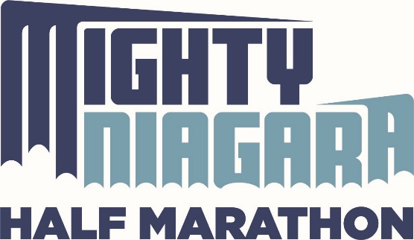Lockport, NY 14094